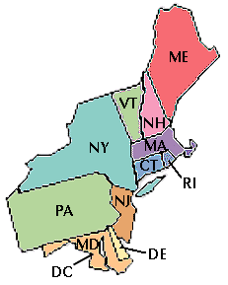
Name: _________________________________________________ Date: ____________________
Northeast Region Project Rubric
Research the 11 Northeast states. Write a one minute radio commercial attracting tourists to this U.S. Region. Be sure that the commercial contains at least one fact for each state. The commercial should include facts having to do with the region’s land or water, products or natural resources, landmarks, and culture. Each team member should participate in each phase of the project (researching, drafting, and recording.) The final audio recording must sound clear and professional.
Criteria | Needs Improvement | Proficient | Exemplary
The commercial script will include a fact for each of the 11 Northeast states. | The commercial omits facts for two or more states. Two or more facts are inaccurate.  20 points | Commercial includes an accurate fact for at least 10 of the 11 Northeast states.  25 points | Commercial includes an accurate fact for all 11 Northeast states.  30 points
The commercial will entice tourists to visit the 11 Northeast states. | The commercial contains 8 or fewer facts that would entice tourists to visit the Northeast.  10 points | The commercial contains 9-10 facts that would entice tourists to visit the Northeast.  15 points | The commercial contains 11 facts (one for each state) that would entice tourists to visit the Northeast states.  20 points
The commercial will include facts that address the Northeast’s land or water, products or natural resources, landmarks, and culture. | The commercial includes facts that address 2 or fewer of the four categories researched.  10 points | The commercial includes accurate facts that address three of the research categories.  15 points | The commercial includes accurate facts from each of the four research categories.  20 points
The audio recording will be clear. The recording will sound professional. | The commercial recording is not clear. The commercial does not model fluent reading that is: accurate, moves at an appropriate rate, and shows expression.  10 points | The commercial recording is mostly clear. The reading is generally fluent. It is contains very few breaks in accuracy. The rate of reading is generally appropriate. The commercial uses some expression to interest the listener.  13 points | The commercial is clear. It models fluent reading that is accurate, appropriately paced, and expressive.  15 points
All team members will participate fully in three phases of the project. (Research, drafting, and recording.) | Team participation in each phase was quite inconsistent. (Research, drafting, and recording.)  10 points | All team members participated in at least 2 phases of the project. (Research, drafting and recording.)  12 points | All team members participated fully in the research, drafting and recording phases of the project.  15 points

Final Grade and Comments:

